**Project Report: JobHub Connect**

**Group – 9 ( Alpha )**

|  |  |  |  |
| --- | --- | --- | --- |
| **S.No** | **FULL NAME** | **STUDENT ID** | **EMAIL** |
| **1.** | PAVAN KALYAN KUDIDALA | 11705031 | pavankalyankudidala@my.unt.edu |
| **2.** | SAINITHIN SINDHE DAMARAGIDDA | 11705464 | sainithinsindhedamaragidda@my.unt.edu |
| **3.** | UDAY KALYAN NUTHALAPATI | 11727451 | udaykalyannuthalapati@my.unt.edu |
| **4.** | VISHAL MIYAPURAM | 11702151 | vishalmiyapuram@my.unt.edu |
| **5.** | SHRAVANI KASULA | 11698782 | shravanikasula@my.unt.edu |
| **6.** | KEERTHI LEKKALA DILLI | 11703021 | keerthilekkaladilli@my.unt.edu |
| **7.** | ABHISHEK KOTRIKE | 11712114 | abhishekkotrike@my.unt.edu |
| **8.** | SAI VENKATA NITHYANANDA REDDY | 11696613 | saivenkatagajjala@my.unt.edu |

**1. Introduction**

**1.1. Purpose**

The purpose of this document is to outline the requirements for the development of JobHub Connect, a job board platform aimed at simplifying the job search process by aggregating job listings from various sources.

**1.2. Scope**

The scope of this project includes the design, development, and deployment of JobHub Connect, focusing on functionalities such as job listing aggregation, user registration, job search, application management, and community engagement.

**1.3. Definitions**

**1.3.1 Job Seekers:**

* + Individuals actively searching for employment opportunities.
  + Create user accounts to access job listings, apply for jobs, and manage applications.
  + Receive personalized job alerts based on preferences.
  + Interact with the platform to track job application statuses.

**1.3.2 Employers:**

* + Companies or organizations looking to hire talent.
  + Create employer accounts to post job listings and manage job postings.
  + Access applicant profiles and manage job applications.
  + Utilize platform features to engage with job seekers and promote employer brands.

**1.3.3 Administrators:**

* + Platform administrators responsible for managing and overseeing the JobHub Connect platform.
  + Manage user accounts, permissions, and access levels.
  + Monitor platform activity, perform system maintenance, and address technical issues.
  + Ensure compliance with regulations and platform policies.

**1.3.4 Community Members:**

* + Users who engage with community features on the platform.
  + Participate in forums, discussions, or chat functionalities to interact with other users.
  + Share job listings, industry insights, or career advice within the platform community.
  + Contribute to building a supportive and collaborative jobseeking community.

**1.3.5 Guest Users:**

* + Individuals who visit the JobHub Connect platform without creating user accounts.
  + Browse publicly available job listings and platform content.
  + Limited access to certain features and functionalities compared to registered users.

**1.3.6 Recruiters/Headhunters:**

* + Professionals or agencies specializing in talent acquisition and recruitment.
  + Utilize the platform to source candidates for job openings.
  + Engage with job seekers and employers to facilitate job placements.
  + Leverage platform features for candidate screening, interviews, and job offers.

**1.3.7 Third-party Integrators:**

* + External systems or services integrated with JobHub Connect for additional functionality.
  + Examples include job portal APIs, payment gateways, analytics platforms, etc.
  + Provide seamless integration to enhance user experience and platform capabilities.
  + Ensure compatibility and data exchange between JobHub Connect and external systems.

**1.3.8 Freelancers/Contractors:**

* + Individuals offering services on a freelance or contract basis.
  + Access job listings for freelance or contract opportunities.
  + Apply for freelance projects or contract positions posted by employers.
  + Manage contracts, deliverables, and payments through the platform.

**2. System Structure:**

**2.1 Subsystems Description:**

**Frontend Subsystem:**

Responsible for the user interface and presentation layer of the platform.

Includes components for user registration, job search, filtering, application management, etc.

Utilizes technologies such as ReactJS, HTML/CSS, and JavaScript.

**Backend Subsystem:**

Manages business logic, data processing, and communication with databases and external services.

Handles user authentication, job listing aggregation, application management, etc.

Implemented using Python with Django or Flask framework.

**Database Subsystem:**

Stores and manages data related to users, job listings, applications, etc.

Includes tables for user profiles, job listings, applications, etc.

Utilizes relational database management systems such as PostgreSQL or MySQL.

**Authentication Subsystem:**

Handles user authentication and authorization processes.

Manages user sessions, access control, and permissions.

Implements security measures such as encryption and secure authentication methods.

**Integration Subsystem:**

Facilitates integration with external job portals and other third party services.

Implements APIs or integration modules to synchronize job listings from external sources.

Ensures seamless data exchange and compatibility with external systems.

**2.1.1 Top Level Description:**In summary, the system structure of JobHub Connect comprises interconnected subsystems that collectively deliver a powerful and user-friendly job board platform, providing job seekers and employers with a centralized hub for efficient job search and recruitment processes. Each subsystem plays a critical role in ensuring the platform's functionality, security, and seamless operation, contributing to JobHub Connect's success in connecting talent with opportunities.

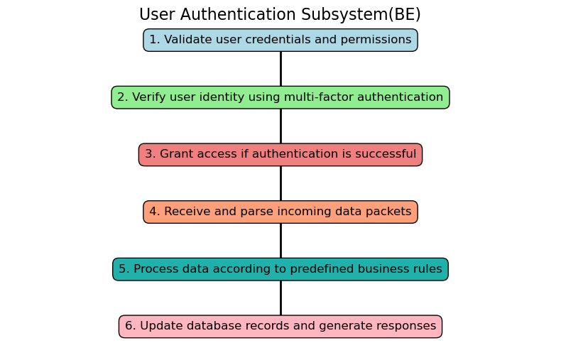

Figure 1: User Authentication Subsystem (BE).

**Authenticate user credentials and permissions:** Verify the user's identity and authorization to access the platform's features.

**Verify user identity using multifactor authentication:** Implement additional security measures such as two factor authentication to ensure user identity verification.

**Grant access upon successful authentication:** Allow authenticated users to access the platform and its functionalities securely.

**Receive and process incoming data packets:** Handle incoming data packets containing user authentication information.

**Apply predefined business rules to process data:** Process authentication data according to predefined rules and logic to validate user access.

**Update database records and generate responses:** Update user authentication records in the database and generate appropriate responses based on authentication status.

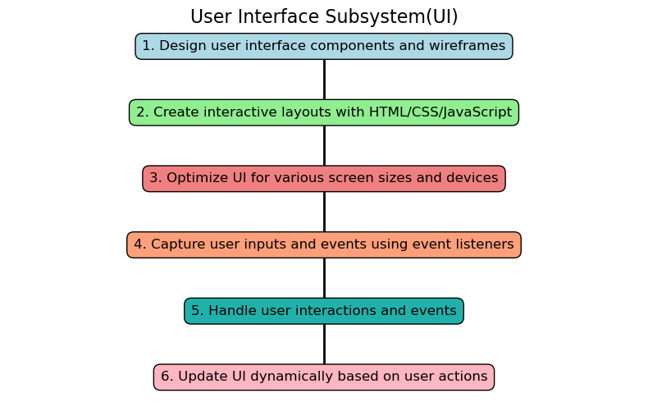

Figure 2: User Authentication Subsystem (UI).

**Design UI components and wireframes**: Create the visual layout and structure of the user interface elements.

**Develop interactive layouts using HTML/CSS/JavaScript:** Implement the UI design using frontend technologies such as HTML, CSS, and JavaScript to create interactive and responsive user interfaces.

**Ensure UI responsiveness for various devices:** Optimize the UI to be compatible and responsive across different devices and screen sizes.

**Capture user inputs and events with listeners:** Implement event listeners to capture user interactions such as clicks, taps, and input.

**Handle user interactions efficiently:** Process user interactions and events to provide a seamless user experience.

**Update UI dynamically based on user actions:** Dynamically update the UI elements in response to user interactions and events.

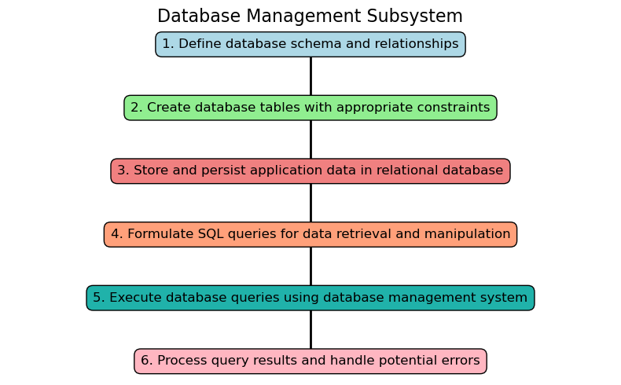

Figure 3: Database Management Subsystem.

**Define database schema and relationships:** Design the structure of the database including tables, fields, and their relationships.

**Create database tables with constraints:** Implement database tables with appropriate constraints such as primary keys, foreign keys, and data types.

**Store and persist application data:** Store and persist data related to users, job listings, applications, and other relevant information.

**Formulate SQL queries for data manipulation:** Create SQL queries to retrieve, insert, update, and delete data from the database.

**Execute queries using DBMS:** Execute SQL queries using the Database Management System (DBMS) to interact with the database.

**Handle query results and errors:** Process query results and handle any errors or exceptions that may occur during database operations.

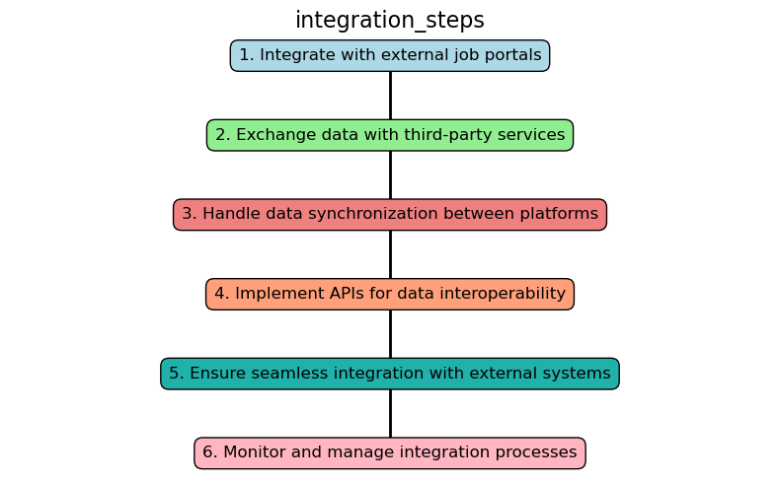

Figure 4: Integration Steps.

**Integrate with external job portals:** Establish connections and integrate the platform with external job portals to aggregate job listings.

**Exchange data with third party services:** Exchange data with third party services such as payment gateways, analytics platforms, and social media platforms.

**Handle data synchronization between platforms:** Ensure data consistency and synchronization between the job hunt platform and external systems.

**Implement APIs for data interoperability:** Develop Application Programming Interfaces (APIs) to enable seamless data exchange and interoperability with external systems.

**Ensure seamless integration with external systems:** Ensure that the integration process is seamless and does not disrupt the user experience or platform functionality.

**Monitor and manage integration processes:** Monitor the integration processes, handle errors or failures, and manage the overall integration workflow.

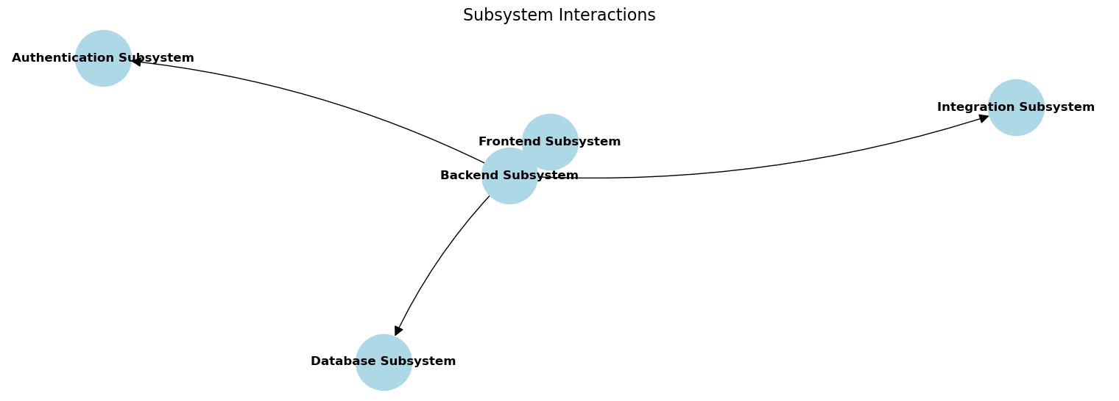

Figure 5: Subsystem Interactions.

**4. REQUIREMENTS SPECIFICATIONS:**

**4.1 Functional Requirements:**

1. The platform will simplify the job application process for job seekers, making it easier for them to apply to various job openings.

2. A user-friendly interface will be provided to guide job seekers through the application process seamlessly.

3. Employers will have access to a centralized platform to review and assess job applications efficiently.

4. Integration with recruitment agencies will offer personalized assistance to job seekers, enhancing their job search experience.

5. The platform will ensure transparency and security throughout the job application process, providing job seekers with confidence in their interactions.

**4.2 Nonfunctional Requirements:**

1. The platform will prioritize efficient workflows and user centric experiences to streamline the job search process.

2. Robust security measures will be implemented to protect the confidentiality of job seekers' personal information and ensure the reliability of the platform.

3. Employers will benefit from real time updates, communication tools, and data analytics to facilitate the recruitment process effectively.

4. The platform is designed to provide comprehensive support to job seekers, especially those exploring opportunities in various industries and locations.

**4.3 Interfaces:**

1. **Job Seeker Portal:** A platform where job seekers can browse job listings, submit applications, and access support services for their job search.

2. **Employer Portal:** An interface for employers to post job openings, review applications, and communicate with potential candidates.

3. **Recruitment Agency Portal:** A user interface for recruitment agencies to collaborate with job seekers, offering tailored assistance and guidance in the job search process.

4. **Admin Portal:** An interface for platform administrators to manage data, user accounts, and platform operations efficiently, ensuring smooth functioning of the platform.

**4.4 Functional Requirement Specifications:**  
  
**4.4.1 Job Seeker Portal:**

**1. Browse Job Listings:**

**Functionality:** Allows job seekers to view available job listings.

**Description:** Job seekers can browse through various job listings to find opportunities that match their skills and interests.

**2. Search for Job by Keywords:**

**Functionality:** Enables job seekers to search for specific jobs using keywords.

**Description:** Job seekers can enter keywords related to job titles, industries, or specific skills to refine their job search results.

**3. Apply for Jobs:**

**Functionality:** Allows job seekers to apply for desired positions.

**Description:** Job seekers can submit their applications for the job openings they are interested in by providing relevant information and documents.

**4. Upload Resume/CV:**

**Functionality:** Provides an option for job seekers to upload their resume or CV.

**Description:** Job seekers can enhance their job applications by uploading their resumes or CVs to provide additional information about their qualifications and experiences.

**5. Receive Application Confirmation:**

**Functionality:** Sends confirmation to job seekers upon successful application submission.

**Description:** Job seekers receive a confirmation message acknowledging the successful submission of their job applications.

**6. Track Application Status:**

**Functionality:** Enables job seekers to track the status of their applications.

**Description:** Job seekers can monitor the progress of their job applications, including whether they have been reviewed, shortlisted, or rejected.

**7. Access Support Services:**

**Functionality:** Provides access to support services for job seekers.

**Description:** Job seekers can access additional support services, such as resume writing assistance, interview preparation tips, and career guidance, to enhance their job search process.

**4.4.2 Employer Portal:**

**1. Post Job Openings:**

**Functionality:** Allows employers to post job openings on the platform.

**Description:** Employers can create and publish job postings to attract potential candidates for available positions within their organizations.

**2. Review Job Applications:**

**Functionality:** Enables employers to review job applications submitted by candidates.

**Description:** Employers can access and evaluate job applications received from candidates who have applied for the posted job openings.

**3. Shortlist Candidates:**

**Functionality:** Allows employers to shortlist candidates based on their qualifications and suitability for the job.

**Description:** Employers can select and shortlist candidates who meet the required criteria for further consideration in the hiring process.

**4. Schedule Interviews:**

**Functionality:** Enables employers to schedule interviews with shortlisted candidates.

**Description:** Employers can arrange interview sessions to assess the skills, experiences, and suitability of shortlisted candidates for the job.

**5. Conduct Interviews:**

**Functionality:** Allows employers to conduct interviews with candidates.

**Description:** Employers can conduct interviews, either inperson or remotely, to evaluate candidates' qualifications, personalities, and fit for the job role.

**6. Select Candidates:**

**Functionality:** Enables employers to select the most suitable candidates for the job.

**Description:** Employers can make final hiring decisions by selecting candidates who best meet the requirements and expectations of the job role.

**7. Communicate with Candidates:**

**Functionality:** Provides communication tools for employers to interact with candidates.

**Description:** Employers can communicate with candidates regarding interview schedules, job offers, negotiations, and other relevant matters through the platform.

These functionalities and descriptions outline the key features and capabilities of the Job Seeker Portal and Employer Portal within the job hunt platform. They facilitate seamless interactions between job seekers and employers, streamlining the job search and hiring processes for both parties.

**4.5 Non-Functional Requirements Specification:**

**Performance:**

* The system should have low latency and quick response times to ensure a smooth user experience.
* It should be capable of handling a large volume of concurrent users without significant degradation in performance.
* Response times for job search, application submission, and other critical actions should be within acceptable limits.

**Reliability:**

* The system should be highly reliable, with minimal downtime and disruptions.
* It should have built in redundancy and failover mechanisms to ensure continuous availability in case of hardware or software failures.
* Data integrity and consistency should be maintained even during system failures or unexpected events.

**Scalability:**

* The system should be scalable to accommodate increasing user loads and growing data volumes over time.
* It should support horizontal and vertical scaling to handle additional users, job listings, and other data without performance degradation.

**Security:**

* The system should adhere to industry-standard security practices to protect user data and sensitive information.
* It should implement secure authentication mechanisms, such as multi factor authentication, to prevent unauthorized access.
* Data encryption should be employed to secure data transmission and storage, including user credentials and personal details.

**Usability:**

* The system should have a user-friendly interface that is intuitive and easy to navigate.
* It should provide clear instructions and guidance to users on how to perform various actions, such as searching for jobs and submitting applications.
* Accessibility features should be incorporated to ensure that the platform is usable by individuals with disabilities.

**Compatibility:**

* The system should be compatible with a wide range of devices, browsers, and operating systems to support diverse user preferences.
* It should be responsive and adaptive, providing a consistent user experience across different devices and screen sizes.

**Maintainability:**

* The system should be modular and well-documented to facilitate ease of maintenance and future enhancements.
* Codebase should follow best practices and coding standards to ensure readability, maintainability, and ease of debugging.
* Regular updates, patches, and bug fixes should be deployed to address any issues and improve system performance over time.

**4.6 Interface Specification:**

|  |  |
| --- | --- |
|  | **Browse Job Listings:** Job seekers start by browsing available job listings on the platform.  **Search for Job by Keywords:** They can search for specific jobs using keywords to narrow down their options.  **Apply for Jobs:** Job seekers can apply for the desired positions by submitting their applications.  **Upload Resume/CV:** Optionally, they can upload their resume or CV to provide additional information to employers.  **Receive Application Confirmation:** Job seekers receive confirmation of their application submission.  **Track Application Status:** They can track the status of their applications to see if they have been reviewed or shortlisted.  **Access Support Services:** Job seekers can access support services for additional assistance or guidance in their job search. |

|  |  |
| --- | --- |
|  | **Post Job Openings:** Employers start by posting job openings on the platform.  **Review Job Applications:** They review the applications received from job seekers for the posted positions.  **Shortlist Candidates:** Employers shortlist candidates based on their qualifications and suitability for the job.  **Schedule Interviews:** They schedule interviews with shortlisted candidates.  **Conduct Interviews:** Employers conduct interviews to assess candidates' skills and suitability.  **Select Candidates:** Based on the interviews, they select candidates for the job.  **Communicate with Candidates:** Employers communicate with selected candidates regarding job offers, negotiations, etc. |
|  | **Collaborate with Job Seekers:** Recruitment agencies collaborate with job seekers to understand their preferences and qualifications.  **Offer Tailored Assistance:** They provide tailored assistance to job seekers, including resume writing, interview preparation, etc.  **Provide Interview Preparation:** Recruitment agencies offer interview preparation services to help job seekers perform well in interviews.  **Coordinate Job Offers:** They coordinate job offers between employers and job seekers.  **Followup with Candidates:** Recruitment agencies follow up with candidates to ensure a smooth hiring process.  **Guidance in Job Search:** They provide guidance and support to job seekers throughout the job search process. |
|  |  |
|  |  |
|  | **Manage User Accounts:** Administrators manage user accounts, including registration, verification, and account settings.  **Monitor Platform Activities:** They monitor platform activities, including job postings, applications, and user interactions.  **Resolve User Issues:** Administrators handle and resolve user issues, complaints, or disputes.  **Manage Data:** They manage platform data, including job listings, user information, and application data.  **Manage Platform Operations:** Administrators manage and oversee the overall operations of the job hunt platform.  **Generate Reports:** They generate reports on platform performance, user engagement, and other relevant metrics for analysis and decision making. |

|  |  |
| --- | --- |
|  |  |

Figure 6: Flow Chart of JobHub Connect

**5. Development Phase Plan**

**5.1 Development Phase 1:** Minimum Viable Product (MVP)

**Front End Requirements (Critical Features):**

* **User registration and login:**
* Allow users to register for an account and log in securely.
* Implement user authentication mechanisms to ensure secure access to user-specific features.
* **Job listing aggregation:**
* Aggregate job listings from various external job portals and display them on the platform.
* Present job listings in a clear and organized manner for easy browsing by users.
* **Basic search functionality:**
* Provide users with basic search capabilities to find relevant job listings based on keywords, location, category, etc.
* Ensure the search functionality is intuitive and responsive.

**Back End Requirements (Critical Features):**

* **User authentication and authorization:**
* Implement robust authentication mechanisms to verify user identities during login and registration processes.
* Enforce authorization rules to control user access to different parts of the platform based on their roles and permissions.
* **Integration with external job portals:**
* Establish connections with external job portals through APIs or web scraping techniques to fetch and aggregate job listings.
* Ensure seamless integration to retrieve updated job data regularly.

**Server Requirements (Critical Aspects):**

* **Reliable hosting infrastructure to ensure uptime.**
* Deploy the application on a reliable hosting infrastructure to ensure high availability and minimal downtime.
* Choose a hosting provider with adequate resources and reliability guarantees to support the initial launch and usage of the platform.

**5.2 Development Phase 2:** Enhanced Functionality

**Front End Requirements (Critical Features):**

* **Advanced Search and Filtering Options:**
* Enhance the search functionality with advanced filtering options such as job type, salary range, industry, etc.
* Allow users to refine their search criteria to find more relevant job listings.
  + **Personalized Job Alerts:**
* Implement a feature for users to set up personalized job alerts based on their preferences.
* Notify users via email or in-app notifications about new job listings matching their specified criteria.

**Back End Requirements (Critical Features):**

* **Application Management for Job Seekers:**
* Provide job seekers with tools to manage their job applications, including tracking application status, saving preferred listings, etc.
* Implement features for job seekers to customize their profiles and resumes.
* **Employer Account Management for Posting Jobs:**
* Enable employers to create and manage their accounts for posting job listings.
* Implement features for employers to manage job listings, track applicant profiles, etc.

**Server Requirements (Critical Aspects):**

* **Scalable hosting infrastructure to accommodate increased traffic:**
* Upgrade the hosting infrastructure to handle increased traffic and user activity resulting from enhanced functionality.
* Ensure the scalability of the server resources to accommodate growing demand and maintain optimal performance.

**5.3 Development Phase 3:** Scalability and Optimization

**Front End Requirements (Critical Features):**

* **Community Engagement Features:**
* Introduce community engagement features such as forums, chat functionalities, or social networking elements.
* Foster interaction and collaboration among users to build a sense of community within the platform.

**Back End Requirements (Critical Features):**

* **Optimization for Performance:**
* Optimize backend systems and databases to ensure fast response times and smooth user experience.
* Implement caching mechanisms, database indexing, and other performance optimization techniques.

**Server Requirements (Critical Aspects):**

* + **Optimization of Server Resources:**
* Fine-tune server configurations and resource allocation to maximize efficiency and minimize resource wastage.
* Monitor and optimize server performance continuously to maintain scalability and optimize costs.

**6. Overall Description**

**6.1. Product Perspective**

JobHub Connect will serve as a centralized platform that aggregates job listings from various sources, providing a user-friendly interface for job seekers to browse, search, and apply for positions. It will integrate with external job portals and sources to fetch and display job listings in a unified manner.

**6.2. Product Features**

* Job listing aggregation from multiple sources
* User registration and profile management
* Advanced search and filtering options
* Personalized job alerts
* Application management tools for job seekers
* Community engagement features for networking and support

**6.3. User Classes and Characteristics**

**Employers:** Individuals or companies posting job listings on the platform.

**Job Seekers:** Individuals searching for employment opportunities.

**Administrators:** Users responsible for managing the platform, including user accounts, job listings, and community engagement.

**7. Team members Description:**

|  |  |  |  |
| --- | --- | --- | --- |
| **Member name** | **Contribution description** | **Overall Contribution (%)** | **Note**  **(if applicable)** |
| Abhishek, Sharavani | Responsible for building user interface with ReactJS | 100% |  |
| Sai Venkata, Vishal | Assists in frontend development tasks | 100% |  |
| Sai Nithin,  Sai Venkata | Leads backend development using Python and Django or Flask | 100% |  |
| Keerthi, Vishal | Supports backend development tasks | 100% |  |
| Sai Nithin,  Keerthi | Manages database setup and optimization | 100% |  |
| Pavan Kalyan, Uday Kalyan | Handles deployment, infrastructure, and server management | 100% |  |
| Uday Kalyan,  Pavan Kalyan | Conducts testing and ensures product quality | 100% |  |